Act6. P-17
1. more than 2000 residents.
2. People who are already dissatisfied with their neighbours.
3. two in five people have complained to their council o r the police.
4. Because people are able to develop some kind of immunity

Act 7a p-17
1.Results: the findings
2.Survey: poll
3.Subjects often discussed or argued about: issues
4. Size/level: Scale
5: Become unaffected by : develop immunity
6. Closely connected with:
7. Not thinking about other peoples feelings: Lack of consideration.
8.

Act7b p-17
1. The government commissioned survey // The study carried out of
2. Designed to measure
3. Was a problem of similar scale // ranked much more highly.
4. The survey also established // The study carried out for // The survey finds

01/10/2020
Act 2 p-20 Speaking and listening
Volcanos
1.True.
2. True. It is one of the biggest Mouna Loa 8.500
3.False. They are in the Pacific ocean.
4. True
5. False. There are volcanos underwater
6. True
7. True. Temperature can raise up to 1250 Celsius
8. False. People go when they are not in eruption
9. True. And people leave near to it.
10. True. It is an active volcano.

Act3. p-20
1 This a class. A professor giving his lecture (lecture es clase de universidad)
2. Teacher and students
3. Five or six.

Act5 p-20
2. Can you tell me if people can go inside volcanos?
3. Would you mind to tell me if Vesuvius is an active volcano?
I would like to know if Vesuvius is an active volcano.
I wonder if Vesuvius is an active volcano.
4.Is it known why volcanoes stop erupting?
5.Could you tell me if that’s true.. // Could you explain… // Could you tell us….

Act6a P-20 En la pagina 128 hay tips de las indirect questions.
Una indirect question es una pregunta dentro de otra pregunta o declaración/enunciado.
2.How many volcanoes erupt each year?
Do you know how many volcanoes erupt each year?
3.What causes a volcano to erupt?
I would like to know what causes a volcano to erupt?
4. What is the biggest volcano in the USA?
Could you tell me which is the biggest volcano in the USA?
5. Which volcano has been showing a lot of activity recently?
I wonder to know which volcano has been showing a lot of activity recently.
6. When did Vesuvius destroy Pompei?
Would you mind to tell me when did Vesuvius destroy Pompei?
7.When did Vesuvius last erupt?
Could you explain when did Vesuvius last erupt?
8.Do a lot of people live near Vesuvius?
Could you tell me if that’s true that a lot of people live near Vesuvius?

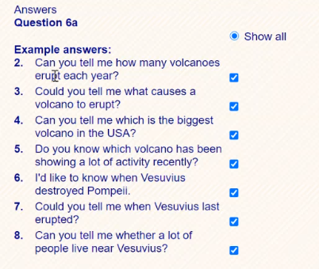
Propuestas del libro como respuesta a la actividad anterior.

La 4 esta mal. El libro esta mal.

Act1 P-21
1.Answer:
Fossil fuels (Coal, gas, oil). These three emit carbon dioxide and they are being used up.
Nuclear power. People thinks it is unsafe.
Renewable energies: Solar, wave and wind power.
Wind farms are unpleasant eyesores. Wind is also variable and unpredictable.
2.Answer:
“The proposal is for a wind farm of eighty turnines over a large area”
“The wind farm will cover an area of several kilometres and take five years to complete”

